Data Science Project Report: Public Opinion Analysis
Subject: Text Mining of YouTube Comments (Jean-Louis Billon)

1. Introduction
The goal of this project was to analyze how people feel about an Ivorian politician. We chose Jean-Louis Billon who is not only an Ivorian politician but also one of the richest businessmen of the country. We choose to analyse comments over three youtube videos from Life TV, France24, and 7info of his post elections era to try to see the public opinion about him. We used Python to collect the data and applied Natural Language Processing (NLP) to understand the main themes and the general mood of the public.

2. Data Collection (Scraping)
We collected 674 comments. For each comment, we kept the Date, the Source (which channel it came from), and the Text. To be sure to have enough data for the analysis and be sure that the comments were before the elections of October 2025 because we wanted to analyse the public opinion for a certain time and be precise in our interpretations.
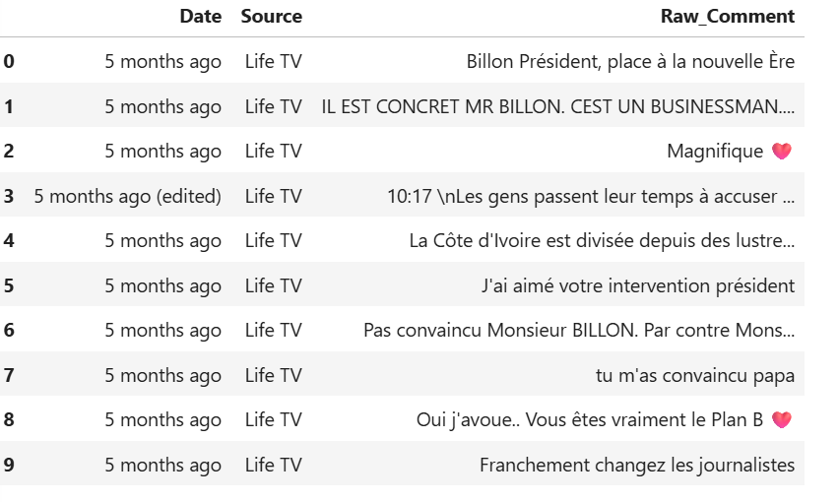
3. Data Cleaning (Preprocessing)
As the text from the internet which are comments in our case are raw and "noisy" because they have emojis, many dots, and useless words. We followed these steps to clean it:
- Cleaning: Removed special characters, citation markers, and extra spaces.This was to reduce the ‘noise’ and be sure that our model will find the real public opinion without being distracted by grammatical noise or symbols.
- Tokenization: Tokenization is the foundational step in our NLP pipeline. It transforms raw sentences into a list of individual words (tokens). This allows our models to perform statistical calculations on the frequency of specific political terms and accurately assess the sentiment of the public discourse.
- Stop-words Removal: Stop words are noisy words that don't have a specific meaning. We filter them out so our models only show the important political themes and feelings people have about Jean-Louis Billon. This makes our results much cleaner and easier to understand.
- Normalization: we used Stemming and Lemmatization to reduce words to their root form (for example, "voter" and "votes" become the same word).This is important because it prevents the computer from treating same words as different topics, giving us a more accurate and simplified view of the public's main concerns.

4. Results and Visualizations

4.1 Theme Extraction (Word Cloud)
The Word Cloud shows us the most prominent words in the debate. The larger the word, the more it was used. In our results, names like 'Thiam' , Billon,Candidate and 'PDCI' were massive, showing that the conversation is not just about one person, but about the future of the PDCI-RDA a party where Jean-Louis Billon was and wanted to be the candidate for the elections but they choose Thiam this clearly show the leadership competition that were in the party just before the elections.Words like "économie" and "business" also appeared, reflecting his background as a businessman.
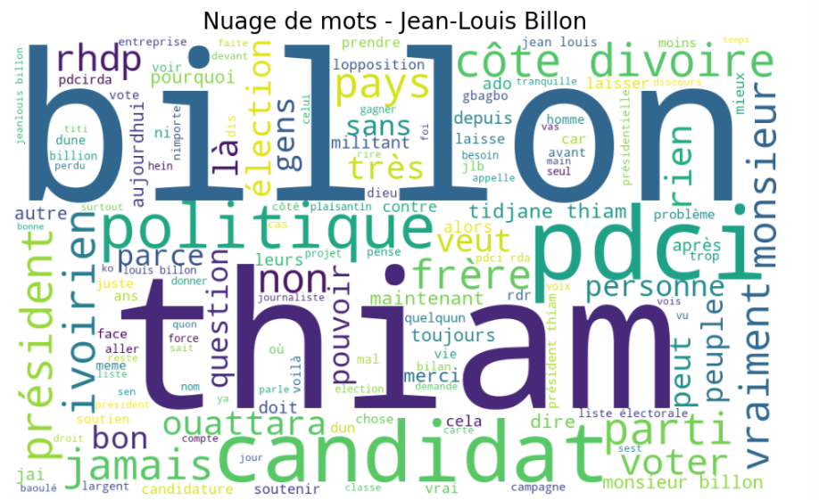

4.2 Sentiment Analysis (The Mood)

We used a library called TextBlob to score every comment from -1 (very negative) to +1 (very positive). We discovered that many supporters use words of praise, while critics often use negations. I specifically improved the code to recognize words like 'Pas' (Not) to ensure that 'Pas convaincu' was correctly marked as Negative.
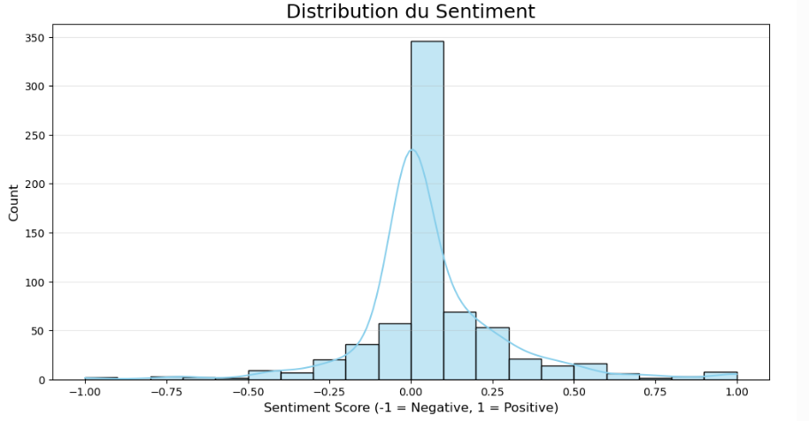
We categorized the comments into three groups: Positive, Neutral, and Negative.
- Positive: Many people expressed support with words like "Magnifique," "Président," or "Bravo."
- Negative: Some users were "Pas convaincu" (not convinced) or criticized the current political situation.
- Neutral: A large portion of comments were neutral, often asking questions or discussing facts without taking a side.
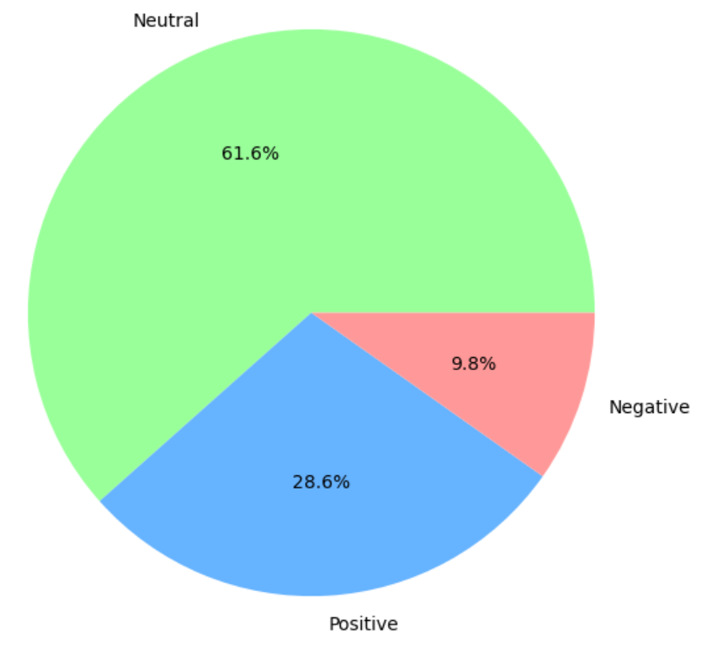

The sentiment distribution shows that the public reaction is mostly Neutral or Slightly Positive. While most commenters stay objective, the positive support for Jean-Louis Billon is significantly stronger than the negative criticism, as seen by the larger 'bump' on the right side of the chart.

5. Conclusion
This project demonstrates that Data Science is not just for numbers. It is a powerful tool ,we can use to apply in any domain. Our analysis of Jean-Louis Billon shows that the public has a supportive and optimistic opinion about him. He is viewed primarily as a competent businessman and a strong political figure within the PDCI. While most people remain objective (Neutral). By using Data Science to clean and analyze the comments, we were able to filter out the 'noise' and prove that the public debate is focused on leadership.

